## OpenClinica

Demo date: Aug 7, 2024  
Scoping start date: Aug 9, 2024

MSA Signature Date: Aug 22, 2024  
Onboarding Kick Off Date: Aug 26, 2024

Go Live Date: Sep 23, 2024

GTM POC: Ben  
Implementation POC: Arjun

ERP: QBO

Tax Integration: No Tax

### 

### Key people at Merchant

### Accountant: [Joe Gilmore](mailto:jgilmore@openclinica.com) - our main POC and super great to work with

* Elisia: Intern that will be helping Joe pull documents, etc, for the transition

### COO: Ben Baumann - likely not involved in the implementation process, but cares deeply about the quality of the switch from Maxio

### 

| AE/ Implementation Notes Sections [Ops International Team to Ignore]   * Info on how merchant bills   + Are there unique things about the customer creation process for this merchant?     1. Customer has a late fee that needs to be applied to either a) a new invoice, or b) the next invoice sent   + Information on how merchant bills     1. Merchant bills for multiple skus as well as blocks of consulting hours that are typically drawn down from, and expire after a certain period of time     2. Most customer’s contracts auto-renew   + How contract is broken up     1. Order forms are fairly straightforward with Skus at the front. There is also a MSA that stipulates renewal terms   + One off things to know about the merchant     1. Switch from Maxio is super important - see the [OpenClinica Checklist for Tabs.xlsx](https://docs.google.com/spreadsheets/d/1m2vx9Talj9rVEba9I39juljFe7-LpTYo/edit?gid=408985659#gid=408985659) * Is there any important merchant relationship information?  Accountant: [Joe Gilmore](mailto:jgilmore@openclinica.com) - our main POC and super great to work with  * + Elisia: Intern that will be helping Joe pull documents, etc, for the transition  COO: Ben Baumann - likely not involved in the implementation process, but cares deeply about the quality of the switch from Maxio 1) What is the merchant temperament? - very excited to switch to Tabs  2) Is there a key POC: (i.e.: who is the buyer/decision maker?) - Joe 3) What are the Tabs features that the key POC cares about? - renewals, and cash forecasting, easy collaboration with CS team for renewals |
| --- |

### 

### Company summary

OpenClinica accelerates clinical trials by automating data acquisition through its software-as-a-service platform. Offering a secure bridge between healthcare and research, OpenClinica is trusted by the world’s foremost life science companies, academic institutions, and government entities and has been used in more than 10,000 studies involving over five million patients. OpenClinica is proud to support hundreds of small, midsize and large research organizations spanning biotech, pharma, medical device manufacturing and contract research organizations.

Goals (North star)

What is the merchant's goal? What pain are we solving? Why are they buying Tabs?

OpenClinica are on Maxio today (have been with them since 2016), and are hugely frustrated with them. They want to replace Maxio with a much easier to use and automated system that still meets parity with Maxio features.

`Some of their biggest pain points:

* Renewals and contract terms and assumptions are frustrating
* Maxio/SFDC sync is frustrating - Joe has to go back and adjust things in SFDC frequently when they come to Maxio
* Had too many team members with access to Maxio and got dinged in their audit because of the risk there (our integrations to slack, etc, will be super helpful here)
* When he gets paid, he has to manually record payment in QBO and push sync to Maxio
* Reporting has been a pain in Maxio

Is there an opt out clause? If so, what is the merchant looking for so they do not exercise it?

No, however they did put together a very important checklist with the features important to them for this switch (essentially making sure we are at least on parity with Maxio)

[OpenClinica Checklist for Tabs.xlsx](https://docs.google.com/spreadsheets/d/1m2vx9Talj9rVEba9I39juljFe7-LpTYo/edit?gid=408985659#gid=408985659)

### Billing model

* Are there unique things about the customer creation process for this merchant?
  + Customer has a late fee that needs to be applied to either a) a new invoice, or b) the next invoice sent
* Information on how merchant bills
  + Merchant bills for multiple skus as well as blocks of consulting hours that are typically drawn down from, and expire after a certain period of time
  + Most customer’s contracts auto-renew
* How contract is broken up
  + Order forms are fairly straightforward with Skus at the front. There is also a MSA that stipulates renewal terms
* One off things to know about the merchant
  + Switch from Maxio is super important - see the [OpenClinica Checklist for Tabs.xlsx](https://docs.google.com/spreadsheets/d/1m2vx9Talj9rVEba9I39juljFe7-LpTYo/edit?gid=408985659#gid=408985659)

### Contract Processing Steps

1. Steps to process
   1. Contract PDFs are generally renewals or new orders.
   2. Start date is usually the most recent of the two signature dates unless stated at the top as a **Subscription Start Date**. September 20th in the following example:
      1. [Arjun to confirm the start date]  
         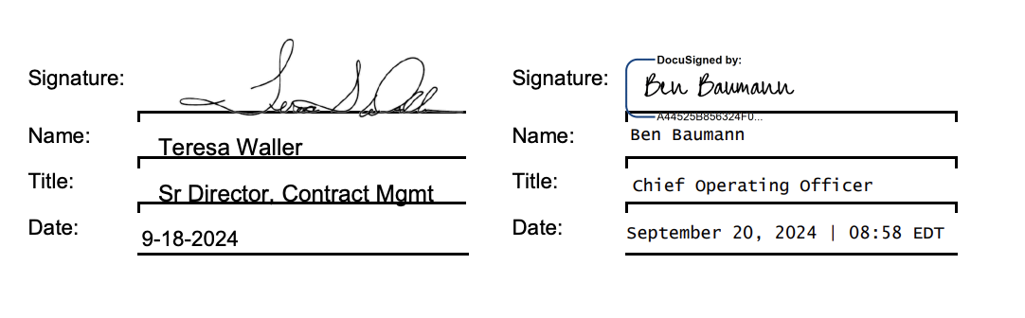
   3. The first column of each row is the name of the item. It is also generally the name of the **Integration Item**. If the name is not in the Integration Item list, look at the small text below and see if that results in a better fit. For example “Rackspace Server” is not an integration item but the small text in the same box says “Oracle-218871-RECURRINGCUSTOMSVC” which corresponds with the integration item “Recurring Custom Service”.   
      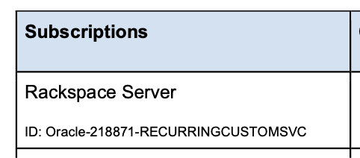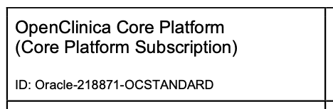
   4. For each group of integration items, a distinct Revenue Schedule should be used. For example, contract <https://garage.tabsplatform.com/prod/contracts/bec9411b-e19c-41f8-8464-476cf8503157/terms/revenue> has 6 rows labeled Recurring Custom Services. They can all be in one revenue schedule.   
      The remaining two rows correspond to Core and Insight which should be in their own revenue schedules and have their own integration items.  
        
      Set the **“Category for Rev Rec”** based on the table below. If the item name does not match anything in the first column, set its revenue category to **Core** and its integration item to **Core**.

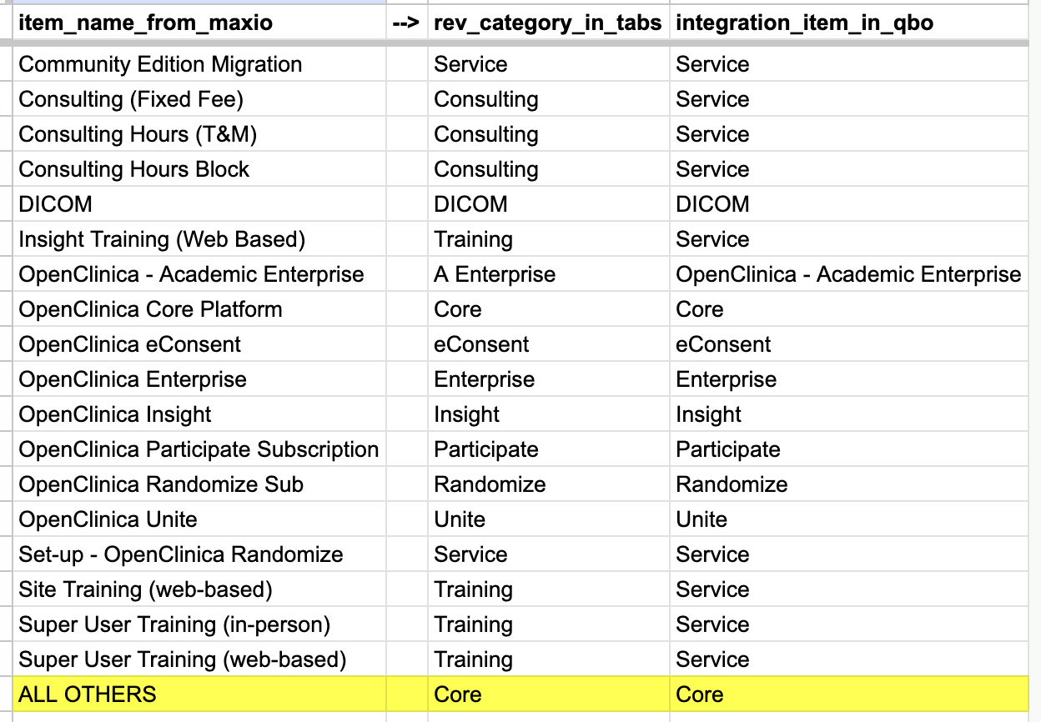

1. Anything to ignore in contracts?  
   Ignore any discounts. Only show the post-discount amounts. For example, in the screenshot below, the billing term should be created as qty=100, unit price = $195.50, total price = $19,550.  
   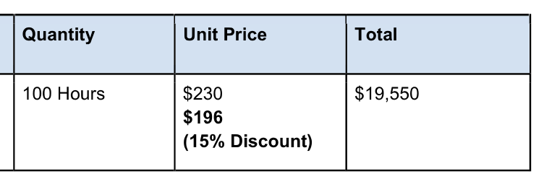

Ignore any late fees.



**Additionally, OpenClinica will now start selling the same product as BuildClinical. These should be processed under OpenClinica, but processing guidelines should be followed based on** [**BuildClinical guidelines**](https://docs.google.com/document/d/1e7EyttTqONvjOsTYO2G44cuz1CgLOFthxEGthJdv_4s/edit?tab=t.0#heading=h.kpy0upq2lmk1) **for these types of contracts.**

1. Specifics processing things the merchant has requested that may differ by contract (e.g. always back-date invoice date to final day of the month)
2. Default Service Term
   1. Generally one year except:
      1. If explicitly stated, follow whatever is in the contract
      2. If it is Training, **service term is 6 months**
      3. If it is Consulting for ≤ 100 hours, **service term is 6 months**
      4. If it is Consulting for > 100 hours, **service term is 12 months**
3. Default Net Payment Terms
   1. Default to Net Terms of 30 Days if not stated in contract.
4. Default Billing Frequency
   1. Default is Annually
   2. If contract states Monthly or Quarterly, follow that instead
   3. Sometimes the ***filename will say the frequency (e.g. “Abbott-218921 bill quarterly.pdf”), which overrides the default and the contents of the contract itself***
5. How do we handle taxes as a line item?
   1. No taxes

### Events / Usage Processing (if necessary)

* No events / usage

Integration Items Processing (if necessary)

* All integration items match the names of the products.
* All revenue schedule names also match the names of the products.



Post Processing Communications (if necessary)

### Customer Information

None

### 

### Rewatch Calls

* Ben and Joe reconnect after initial chats in May standard demo - <https://tabs.rewatch.com/video/k5zov4glmu9rcwh8-hold-joe-ben-reconnect-august-7-2024>
* Ben + Joe do custom demo - <https://tabs.rewatch.com/video/4pk8ppheluylryii-tabs-openclinica-august-9-2024>
* Rebecca meets with Joe - <https://tabs.rewatch.com/video/71wn25ipt7gwxd67-tabs-openclinica-sync-on-maxio-switch-august-13-2024>
* Rebecca and Ali meet with Joe and COO Ben Baumann - <https://tabs.rewatch.com/video/zcd4f2jmcat3hyur-tabs-openclinica-review-august-16-2024>
* Rebecca, Ben and Arjun meet with Joe to scope their needs switching over from Maxio - <https://tabs.rewatch.com/video/olmtk1y3hlz557nb-openclinica-tabs-august-21-2024>
* Sync to discuss moving forward, and Joe’s needs around renewal data in Cash forecasting - <https://tabs.rewatch.com/video/tzhkwhkc39kp6gwt-joe-ben-rebecca-sync-august-22-2024>